**Use FTP and “FileZilla” to manage web files**

Go to:

<http://members.000webhost.com/login.php>

and login

**email**: [dm.vakhrushev@gmail.com](mailto:dm.vakhrushev@gmail.com)

**password**: anchufaka27

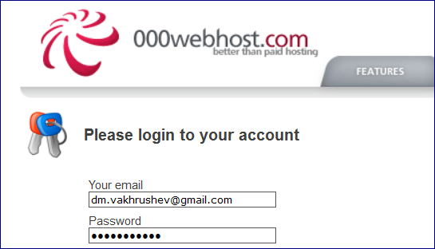

**Once you are in you’ll see the following screen:**

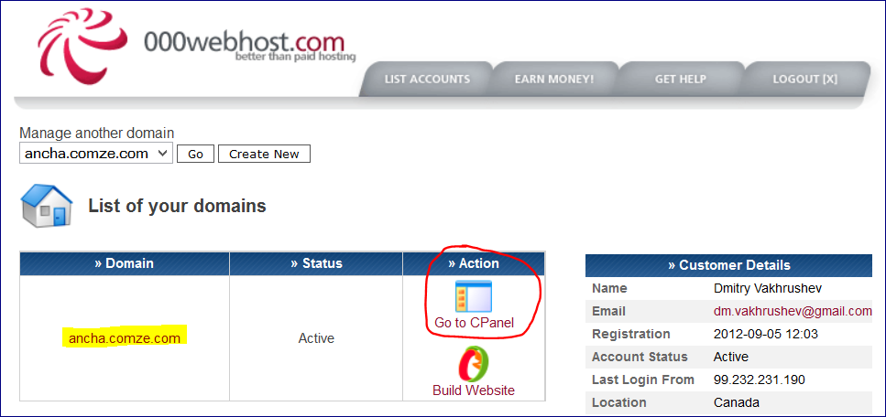

This is the name of website I own:

[**http://ancha.comze.com/**](http://ancha.comze.com/)

**or** [**http://www.ancha.comze.com**](http://www.ancha.comze.com)

**To manage website files click “Go to CPanel”**

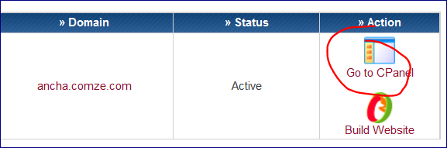

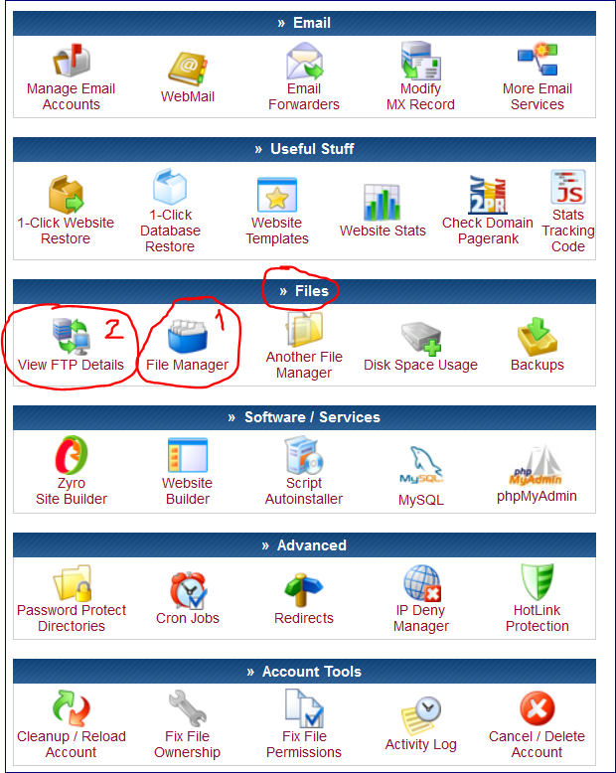

**Go to “Files” section 🡪 View FTP Details**

FTP Accounts allow you to access your web site's files through a protocol called FTP. You will need a third party FTP program to access your files. If you do not know anything about FTP you may use our web based [*File Manager*](http://members.000webhost.com/actions.php?action=filemanager&accountID=10988277&login_hash=WC5jllDQwMAi4Gyz) to upload your files.

http://members.000webhost.com/images/forwarder_small.gif**FTP details for *ancha.comze.com***

|  |  |
| --- | --- |
| **FTP host name** | **ancha.comze.com** |
| **FTP user name** | **a8655307** |
| **FTP password** | **anchufaka27** |
| Folder to upload files | public_html |
| Forgot FTP password? | [Change account password](http://members.000webhost.com/panel/change_account_password.php?accountID=10988277&login_hash=WC5jllDQwMAi4Gyz) |
| Recommended FTP clients | [SmartFTP](http://www.smartftp.com/download/) or [**FileZilla**](http://filezilla-project.org/download.php?type=client) |

Now Go to “Files” section 🡪 File Manager

And input your FTP user name and FTP password

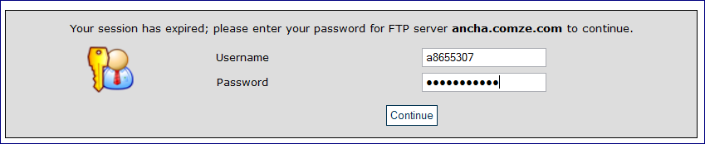

We’ll get the screen below.

Click “**public_htm**” 🡪 this is the place where the web files should be placed in order to be visible.

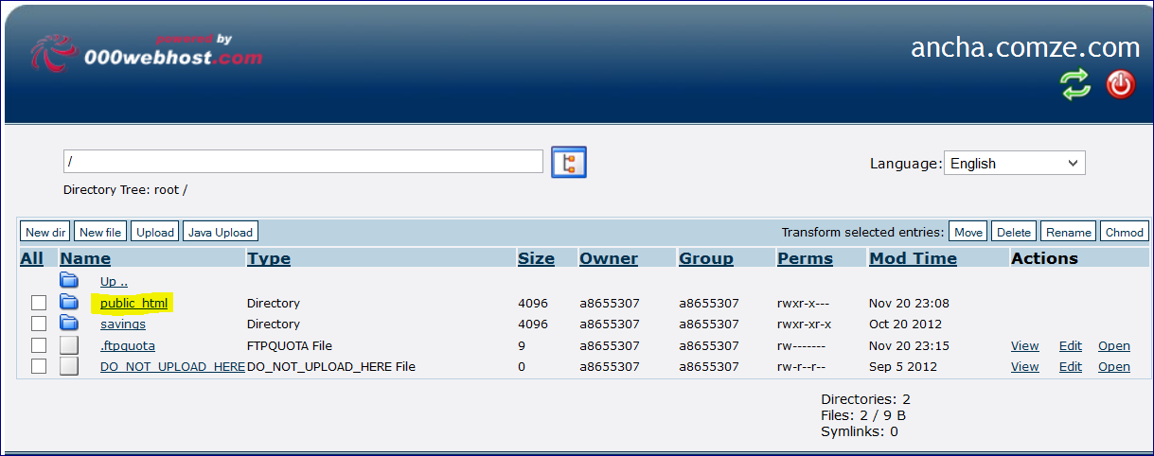

Here we can manage our files

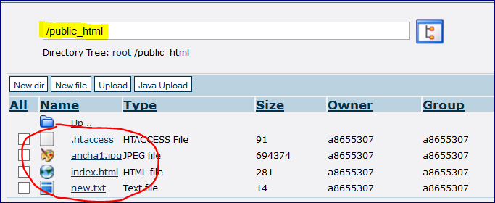

--========================================================================

**The second approach to update files is to use FTP client, e.g. FileZilla.**

Run FileZilla

Connect to your FTP Server:

**FTP details for *ancha.comze.com***



|  |  |
| --- | --- |
| **FTP host name** | **ancha.comze.com** |
| **FTP user name** | **a8655307** |
| **FTP password** | **anchufaka27** |
| Folder to upload files | public_html |
| Forgot FTP password? | [Change account password](http://members.000webhost.com/panel/change_account_password.php?accountID=10988277&login_hash=WC5jllDQwMAi4Gyz) |
| Recommended FTP clients | [SmartFTP](http://www.smartftp.com/download/) or [**FileZilla**](http://filezilla-project.org/download.php?type=client) |

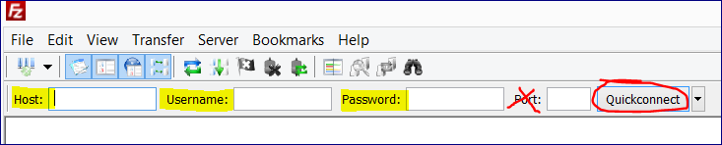



Now we can drug and drop files

Copy, delete, update and etc.

